# Final Year Project Documentation

## SQL Travels – Explore Sri Lanka with Queries

### Game-Based Learning Platform using the ADDIE-GDLC Hybrid Model

## 1. Introduction

**Overview:** “SQL Travels – Explore Sri Lanka with Queries” is a game-based learning platform aimed at teaching Structured Query Language (SQL) through an interactive and story-driven experience. The game follows a tourist traveling across Sri Lanka’s nine provinces, where each province represents a learning level focused on a specific SQL concept.

**Why Gamification:** Traditional methods of teaching SQL can be monotonous and disengaging. By incorporating gamification and narrative-based progression, this platform keeps learners motivated and promotes better retention through active problem-solving in real-life contexts.

**Target Audience:**

* Undergraduate IT and Computer Science students
* Self-learners pursuing database knowledge
* Beginners preparing for database certifications

**Instructional & Developmental Model:** The platform is designed using a hybrid model:

* **ADDIE**: For structured instructional design and learning outcomes
* **GDLC (Game Development Life Cycle)**: For end-to-end game development lifecycle

## 2. Learning Model Used: ADDIE-GDLC Hybrid

### **ANALYZE**

### **Learning Problem:**

### Traditional SQL education relies heavily on syntax drills and textbook examples that often feel disconnected from real-life applications.

### Lack of motivation, low engagement, and difficulty in applying concepts in practical scenarios are major barriers.

### Limited interactivity and visual learning tools reduce retention, especially for Gen Z learners.

### **Identified Needs:**

### A gamified learning environment where SQL is taught through **contextual storytelling**, **visual exploration**, and **real-life tourism-based tasks**.

### Progressive difficulty and **adaptive feedback** to support different learning paces and styles.

### Features like **immediate feedback**, **leaderboards**, and **rewards** to boost motivation.

### **Target Audience:**

### Age: 18–25 years

### Background: Undergraduate IT or computer science students with beginner to intermediate knowledge of programming.

### Interests: Technology, travel, gaming, and interactive learning.

### **Learning Environment:**

### Accessible via **mobile** and **web** to support remote learning.

### Compatible with **MySQL/PostgreSQL** databases for real-world relevance.

### Usable in **labs, homes, or classrooms**, and suitable for **self-paced** or **guided academic** use.

### **DESIGN**

### **Learning Objectives by Province/Level:**

| **Province** | **SQL Topic(s)** | **Challenge Type Example** |
| --- | --- | --- |
| Western | SELECT Basics | Find hotel names in Colombo |
| Central | WHERE, ORDER BY | Sort hotels by price under a certain budget |
| Southern | GROUP BY, HAVING | Count tourists grouped by attraction type |
| Northern | JOIN | Join tourist and booking tables |
| Eastern | INNER JOIN, LEFT JOIN | Retrieve all attractions with/without reviews |
| North Central | Nested Queries | Find hotels in cities with the highest ratings |
| Uva | Views | Create reusable view for top-rated hotels |
| North Western | Aggregates | Calculate average trip duration by tourist type |
| Sabaragamuwa | DDL & Optimization | Create and optimize tables for new packages |

### **Instructional Strategy:**

### **Story-based Tasks:** Players solve SQL problems while booking accommodations, filtering locations, or analyzing tourist data.

### **Gamification Elements:**

### **XP (Experience Points)** for correct answers

### **Coins** to unlock hints or skip questions

### **Achievement Badges** for milestones

### **Adaptive Learning:**

### If the user fails 2–3 times, **adaptive hints** appear

### Skipping is allowed with a penalty (e.g., fewer coins)

### **Visual Feedback:**

### Immediate color-coded validation (Green: Correct, Red: Incorrect)

### Explanation pop-ups after submission

### **DEVELOPMENT**

### **Technology Stack:**

### **Frontend:**

### Android (Kotlin) for mobile

### React.js for web

### **Backend:**

### Node.js or PHP (REST APIs)

### **Database:**

### MySQL or PostgreSQL

### **Tools:**

### Firebase or Supabase (optional for auth & analytics)

### GitHub for version control

### Figma for UI/UX mockups

### **Key Functional Modules:**

### **SQL Compiler/Auto-Evaluator:**

### Validates and runs user SQL queries in a sandboxed environment.

### Compares with pre-defined correct answers or result sets.

### **Free Practice (Sandbox Mode):**

### Open-ended playground to try queries outside the main storyline.

### **Interactive Map:**

### Clickable Sri Lankan map to choose provinces

### Shows unlock status and stars earned

### **Narrative Engine:**

### Cutscenes, character interactions, and storyline progress

### Travelogue-style storytelling (with voice-overs optionally)

### **Audio/Visual Assets:**

### Background music, ambient sounds (waves, birds, city), visual animations

### **IMPLEMENTATION**

### **Beta Testing:**

### Conduct beta with **10–15 students** (IT undergrads).

### Record usability sessions, gather feedback, and identify bugs or confusion points.

### **User Onboarding:**

### **Interactive tutorial** introducing map, gameplay mechanics, and SQL editor

### **Step-by-step guidance** in the first level to ensure understanding

### **Deployment:**

### **Mobile APK** for Android phones/tablets

### **Web PWA (Progressive Web App)** for desktop and iOS browser access

### **Integration with Moodle or LMS:**

### Allow teachers to track progress

### Exportable reports for assignments and quizzes

### **EVALUATION**

### **Quantitative Metrics (Tracked via Backend Analytics):**

### **Query accuracy** rate (correct attempts vs total)

### **Average attempts per challenge**

### **Time per level** and **time per query**

### **Completion rate** of each province

### **Sandbox usage statistics**

### **Qualitative Feedback:**

### Embedded **in-app feedback** system after completing each province

### Google Forms for detailed end-of-game surveys

### Periodic feedback prompts (e.g., after level 3 and level 6)

### **Teacher Evaluation Tools:**

### Exportable CSV reports on player performance

### Ability to view incorrect query history for each student

### Class leaderboard view (for use in academic environments)

### 🔹 2.2 GDLC Integration

* **Concept Phase:**
  + Tourist travels to discover culture while solving SQL missions
  + Each province is a level, every challenge is a real-world query problem
* **Pre-Production:**
  + Design story arcs, key levels, dialogues
  + Define avatars and map layout
* **Production:**
  + Develop province maps and mission structures
  + Build UI/UX screens for gameplay
  + Write backend logic for SQL validation and feedback
* **Testing:**
  + Unit testing for SQL evaluator
  + Manual gameplay testing for bug fixing
  + Test learning outcomes with control group
* **Release & Post-Release:**
  + Publish app
  + Collect performance data
  + Push updates with new query types and multiplayer features

### **🔹 2.3 Main Characters and Roles**

| **Character** | **Role in Story** | **Educational Purpose** |
| --- | --- | --- |
| Alex (The Tourist / Player) | The main character controlled by the player. Recently arrived from Europe to explore Sri Lanka. | Represents the learner. Learns SQL by solving contextual tasks. |
| Nila (Local Guide) | A friendly Sri Lankan local who guides Alex through each province, gives hints, and shares fun facts. | Acts as the in-game tutor. Provides adaptive feedback and optional SQL tips. |
| Professor Senanayake (Database Expert) | A quirky professor working on a tourism data project. Helps explain complex SQL concepts. | Introduces SQL topics via mini-tutorials and visual aids. |
| Ravi (Transport Driver) | Drives Alex between provinces and cracks jokes. Appears during loading scenes. | Adds comic relief and cultural context; shows travel progress. |
| Leaderboard Ghosts | Shadow profiles of other tourists from the global leaderboard. | Adds motivation and competition via leaderboard-based learning. |
| Quiz Master (Optional Character) | Appears in bonus missions offering timed challenges and puzzles. | Provides skill assessments and rewards for advanced learning. |

### **🔹 2.4 Story Flow Across Provinces**

Alex, a curious and tech-savvy tourist from Europe, arrives at Bandaranaike International Airport, filled with excitement to explore the vibrant island nation of Sri Lanka. With a passion for travel and a remote tourism data project in hand, Alex decides to combine cultural exploration with hands-on learning by documenting the journey using SQL queries. At the airport, Alex meets Ravi, a witty and enthusiastic local cab driver who instantly connects with Alex and offers to be the guide for a province-by-province tour of the island. As they shake hands, Ravi gifts Alex a “Travel Log” — a digital journal where achievements, queries, regional facts, and collectibles will be recorded throughout the adventure.

Their journey begins in Colombo, capital of the Western Province, where Alex checks into a hotel and meets Nila, a knowledgeable local data mentor and Ravi’s tech-savvy cousin. Nila introduces Alex to the SQL Terminal; a smart virtual assistant built into Alex’s tablet. With its help, Alex writes the first query using SELECT * to retrieve hotel listings — earning the “Query Beginner” badge and unlocking the first Map Star on the interactive travel map. Hidden in a local café, Alex also discovers their first Easter Egg: a retro SQL joke in a QR code on the menu.

Next, the duo boards a scenic blue train to Kandy in the Central Province, visiting the sacred Temple of the Tooth Relic and tasting local Kiri Bath. While relaxing by Kandy Lake, Alex learns to filter and sort hotel data using WHERE and ORDER BY. A mini-game challenge called “Filter Frenzy” allows Alex to earn bonus coins by quickly answering a series of multiple-choice SQL conditions. Completing this level adds a collectible Temple Token to the Travel Log.

Heading south, they ride a colorful tuk-tuk to Galle in the Southern Province, exploring the iconic Galle Fort, surfing at Unawatuna Beach, and participating in the "Beach Budget Challenge", where Alex ranks tourist destinations using ORDER BY while managing a virtual travel budget. A hidden camera mini-game lets players unlock Photobook Snaps — a collectible gallery of scenic landmarks.

A quick domestic flight brings them to Jaffna in the Northern Province, where the cultural charm of the Nallur Kovil awaits. Alex learns about data relationships by working with JOIN operations to connect tourists and bookings. A "Data Pairing Puzzle" mini-quest tests Alex's ability to form accurate SQL joins. A hidden library in the game reveals the "Jaffna Codex" — a side journal with advanced SQL tips, unlockable only after solving bonus queries.

Traveling eastward, they reach Batticaloa in the Eastern Province, where Alex walks along the Dutch Fort walls and relaxes at Pasikuda Beach. Here, Alex learns to use GROUP BY for tourism stats, unlocking Pie Chart Mode, where query results come to life through animated visuals. A "Data Dive" diving game lets Alex collect Data Pearls, which can be traded for hints.

A jeep adventure through Anuradhapura in the North Central Province leads Alex to ancient stupas and sacred Bodhi trees. Here, the game introduces HAVING clauses to filter grouped data. A challenge called “Sacred Stats” has Alex help a virtual monk plan festival arrangements using grouped queries. Completing the mission rewards the Golden Bo Leaf Badge.

The legendary hill train to Badulla in the Uva Province offers breathtaking views of the Nine Arches Bridge and Dunhinda Falls. Anomalies in temple data lead to a hidden quest — The Lost Temple Mystery, where Alex uses subqueries to uncover the location of a forgotten shrine. Unlocking this level opens up the Shadow Temple, a mini dungeon-like simulation requiring logical reasoning, and rewards a Mystic Relic on completion.

In Ratnapura, the gem capital of the Sabaragamuwa Province, Alex starts a travel blog after visiting the Gem Museum and Bopath Ella Waterfall. Here, real-time changes to the tourism dataset are practiced using INSERT, UPDATE, and DELETE. A Gem Crafting Simulator gives players a hands-on UI to edit tables, earning Gem Points used for customizing avatars and unlocking cheat sheets.

Finally, the duo arrives in Kurunegala in the North Western Province, where Alex visits Athugala Rock (Elephant Rock) and meets Professor Senanayake, a renowned data scientist. The professor presents a Final Boss Battle — a timed, multi-phase SQL simulation requiring mastery of all learned concepts: JOINS, GROUP BY, SUBQUERIES, VIEWS, and constraints. Successfully passing the challenge earns Alex the "SQL Master Explorer" title, a downloadable Certificate of Completion, and the final Map Star, unlocking New Game+ mode with randomized queries.

The story concludes with a virtual “Graduation Ceremony”, where Alex’s character is featured on the Global Leaderboard, alongside Ravi and Nila, cheering on the achievement. As fireworks light up the digital Sri Lankan skyline, the player is left with a sense of accomplishment — having turned a scenic vacation into a rich and unforgettable journey of learning, adventure, and discovery through SQL.

🔹 **2.4 Scene: Jaffna – The Data Pairing Puzzle**

**Setting:**  
The warm breeze flows through the red walls of **Nallur Kandaswamy Kovil** as temple bells echo in the distance. Alex, accompanied by Ravi and Nila, arrives at the **Jaffna Tourism Information Center**, where Professor Senanayake has left a challenge: a **Data Pairing Puzzle** to help the center organize tourist booking records.

Inside, a virtual assistant projects two database tables on a floating screen:

TOURISTS

+------------+-----------+----------+------------+

| tourist_id | name | country | age |

+------------+-----------+----------+------------+

| 1 | Emma | UK | 29 |

| 2 | Haruki | Japan | 34 |

| 3 | Sofia | Spain | 26 |

| 4 | Ahmed | Egypt | 31 |

+------------+-----------+----------+------------+

BOOKINGS

+------------+-------------+------------+------------+

| booking_id | tourist_id | hotel_id | check_in |

+------------+-------------+------------+------------+

| 101 | 1 | 501 | 2025-07-10 |

| 102 | 2 | 504 | 2025-07-11 |

| 103 | 4 | 502 | 2025-07-12 |

+------------+-------------+------------+------------+

**Objective:**  
The player (Alex) must join the TOURISTS and BOOKINGS tables to display a list of all tourists who made bookings, along with their name, country, and check-in date.

**Player’s First Attempt (Incorrect):**

SELECT name, country, check_in

FROM tourists, bookings

WHERE tourist_id = tourist_id;

*Result:* An error appears, or an incorrect cartesian product output.

**Nila’s Adaptive Hint (Trigger after 2 failed attempts):**

**Nila (in-game guide):**  
"Hmm, looks like we’re joining the tables — but remember, if both tables have the same column name, we should specify the table name to avoid confusion. Try using table aliases for clarity!"

Suggested Correct Query:

SELECT t.name, t.country, b.check_in

FROM tourists t

JOIN bookings b ON t.tourist_id = b.tourist_id;

*Result:* Correct output with matched tourist data and check-in dates.

**Bonus Challenge – Unlocking the "Jaffna Codex"**

A locked bookshelf appears with a golden SQL lock icon.

*Unlock Code:* Write a query that shows only tourists who booked after July 10, 2025, and are above 30 years old.

SELECT t.name, t.age, b.check_in

FROM tourists t

JOIN bookings b ON t.tourist_id = b.tourist_id

WHERE b.check_in > '2025-07-10' AND t.age > 30;

*Reward:* The **"Jaffna Codex"** unlocks with scrolls revealing:

* Nested JOIN tips
* Visual JOIN diagrams
* "JOIN vs. LEFT JOIN" guide
* Optional side puzzle: "Find tourists with no bookings" using LEFT JOIN and IS NULL.

Summary of Learning Outcomes in This Scene:

* How to correctly use JOIN with ON conditions.
* Importance of table aliases (t, b) for clarity.
* Real-world scenario: tourists and bookings.
* Adaptive help when failing.
* Side quest introducing JOIN + WHERE combo.
* Bonus: Prepares learner for LEFT JOIN + filtering NULLs.

**Images of game by provinces**

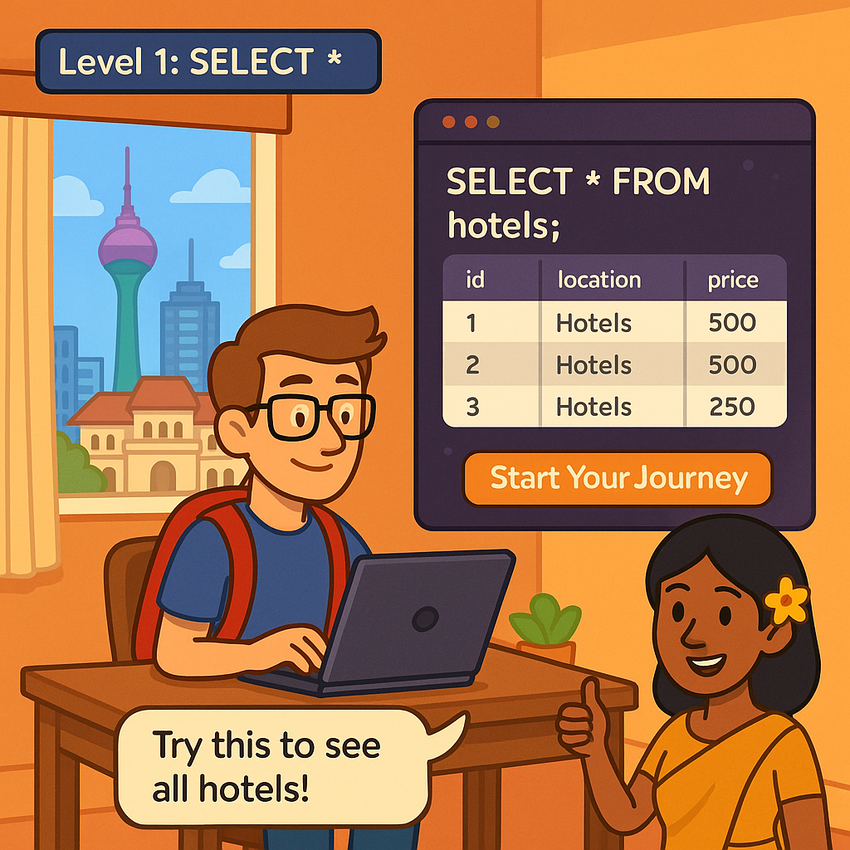

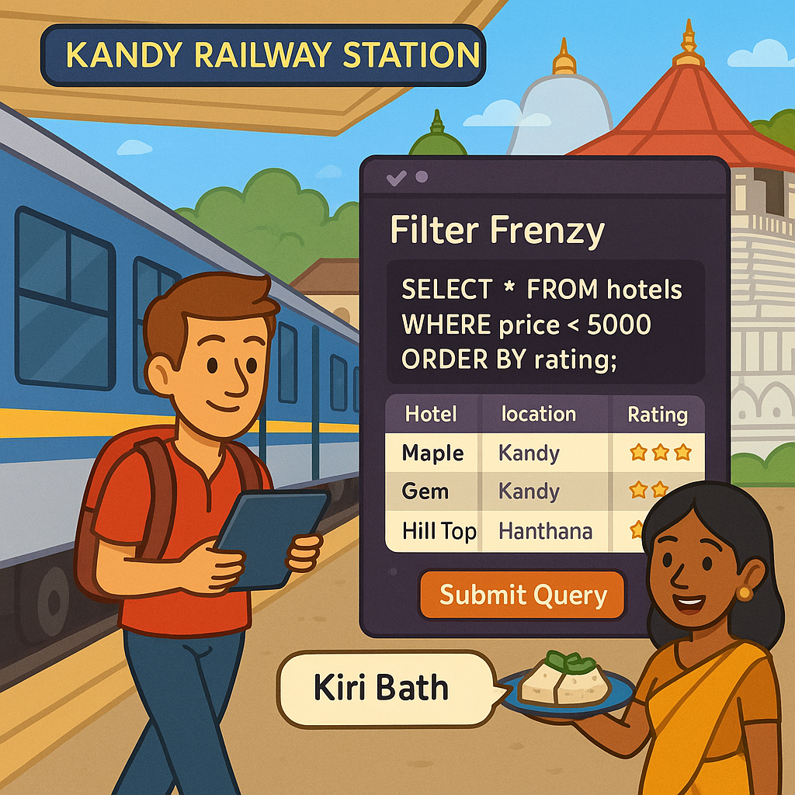

## 

## 

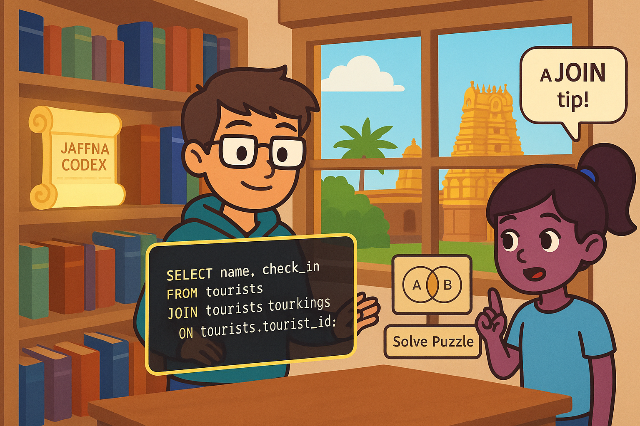

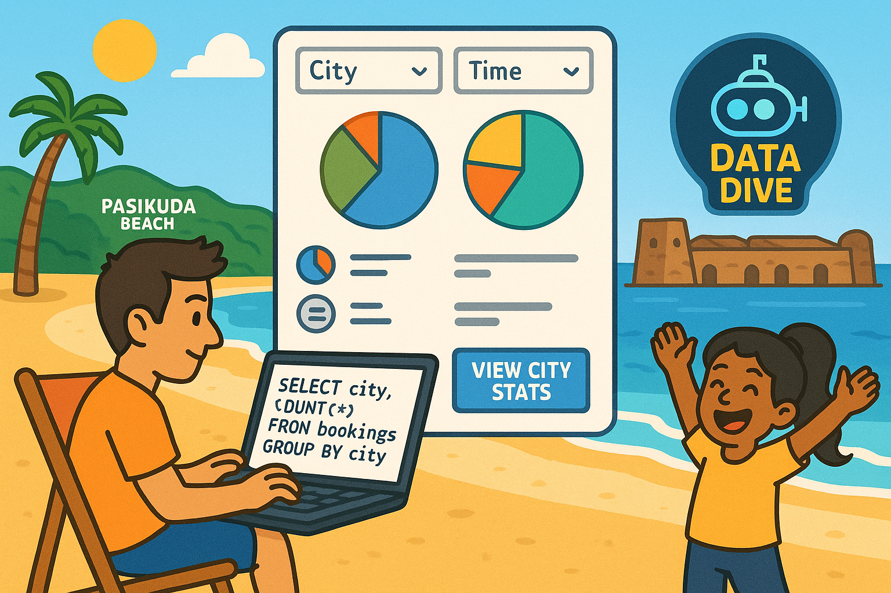

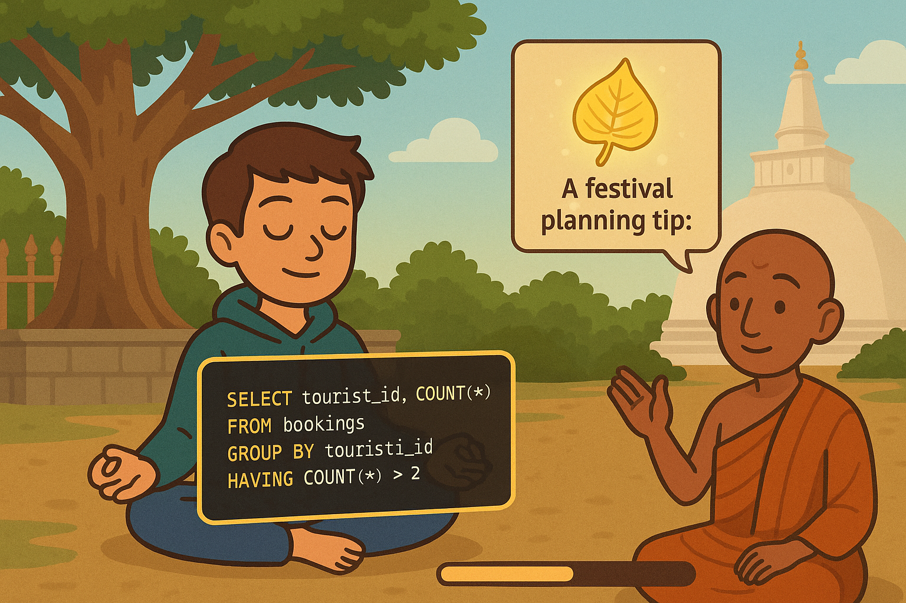

## 3. System Architecture

### 3.1 Use Case Diagram

Key actors: Player (Tourist), System Use Cases:

* Register/Login
* View Province Map
* Select Level
* View SQL Challenge
* Submit SQL Query
* Receive Feedback
* View Hints
* Earn Achievements
* Replay Challenges

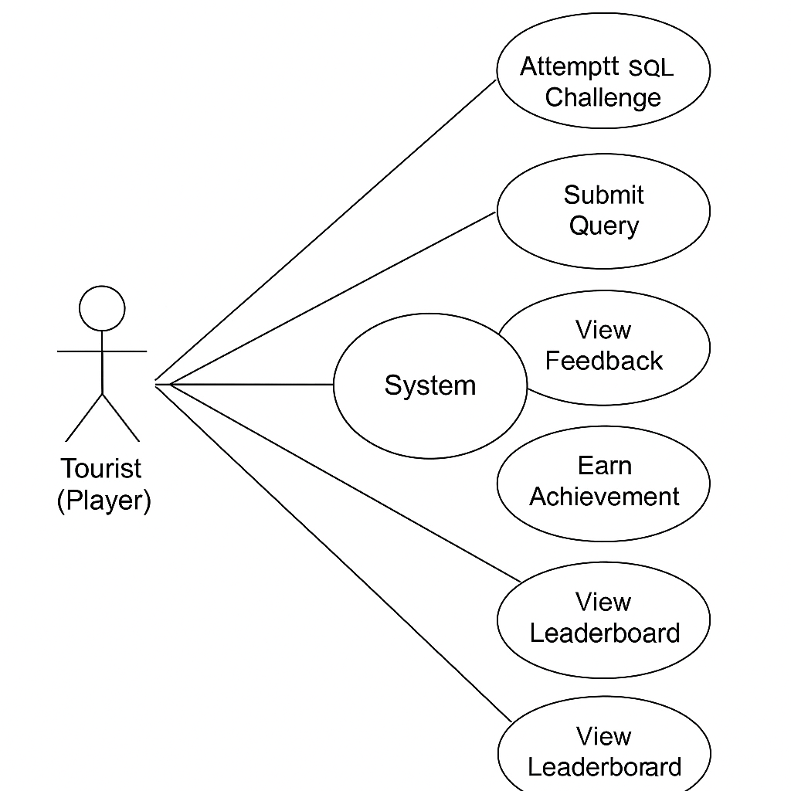

### 

### 3.2 ER Diagram

**Entities:**

* Tourist(tourist_id, name, email, password)
* Province(province_id, name, level_theme)
* Hotel(hotel_id, name, province_id, price)
* Booking(booking_id, tourist_id, hotel_id, date)
* Achievement(achievement_id, name, condition)

**Relationships:**

* One tourist → many bookings
* One booking → one hotel
* One hotel → one province
* One tourist → many achievements

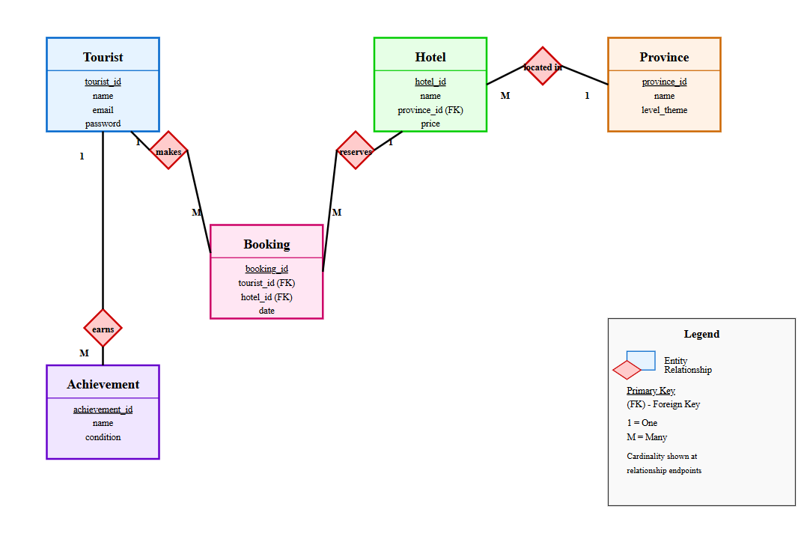

3.3 System Flow

Login → Map Screen → Select Province → SQL Challenge → Run Query → Feedback → Unlock Next → Save Progress

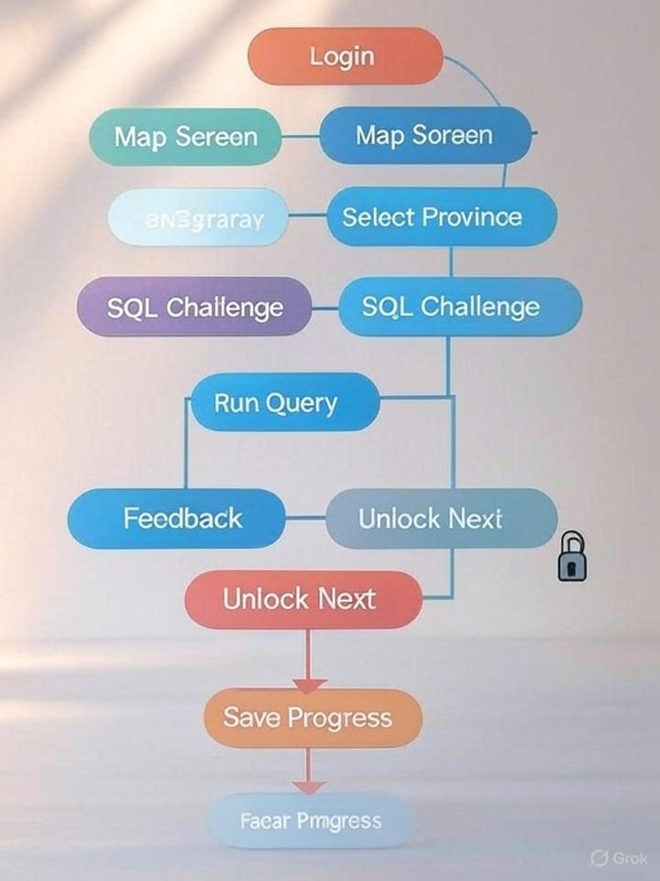

## 4. Game Mechanics

### 🔹 4.1 Game Flow

Each province = 1 SQL Level:

1. Start in Western Province: Learn SELECT
2. Travel unlocked on completing each challenge
3. Tourist budget reduces with hints or incorrect answers
4. Mission-based: e.g., “Find the cheapest hotel in Kandy”
5. After successful query, animation plays, and next province unlocks

**Western Province – Level 1: SELECT \***

**Learning Focus**: Retrieving complete rows from tables  
**Gameplay Flow**:

1. **Story Intro**: The tourist lands in **Colombo**, looking for accommodation and local attractions.
2. **Mini Tutorial**: "SELECT * FROM hotels" explained using animations.
3. **Challenges**:
   * View all hotels in Colombo.
   * Show all columns from the tourists table.
   * List every hotel and its city.
4. **Help**: Tooltip on table names, autocomplete for query input.
5. **Rewards**: “Query Beginner” badge, unlock Central Province.

**Central Province – Level 2: WHERE**

**Learning Focus**: Filtering rows with conditions  
**Gameplay Flow**:

1. **Story**: The tourist arrives in **Kandy**, wants budget-friendly hotels and meets other tourists.
2. **Tutorial**: Filtering with WHERE, basic operators.
3. **Challenges**:
   * Find hotels in Kandy under Rs. 5000.
   * Show tourists from Germany.
   * Find 3-star hotels with Wi-Fi.
4. **Hint System**: Syntax examples (“WHERE column = value”).
5. **Outcome**: Unlock next location, adjust travel budget depending on performance.

**Southern Province – Level 3: ORDER BY**

**Learning Focus**: Sorting results  
**Gameplay Flow**:

1. **Story**: The player reaches **Galle**, known for scenic beaches.
2. **Tutorial**: ORDER BY basics – ASC, DESC.
3. **Challenges**:
   * List top-rated beaches.
   * Sort hotels in Galle by price.
   * Display tourists in alphabetical order.
4. **New Mechanic**: Leaderboard for time-based sorting challenge.
5. **Reward**: “Sorting Explorer” badge, next train to Jaffna.

**Northern Province – Level 4: JOIN**

**Learning Focus**: Combining tables  
**Gameplay Flow**:

1. **Story**: Arrival in **Jaffna**. The tourist needs booking info.
2. **Tutorial**: JOIN types (INNER JOIN focus).
3. **Challenges**:
   * Show tourist names and the hotels they booked.
   * List bookings made in Jaffna with check-in dates.
   * Retrieve hotel name and province name in one query.
4. **Support**: Diagrammatic view of JOIN operations.
5. **Unlock**: Access to Eastern Province + new Practice Mode features.

**Eastern Province – Level 5: GROUP BY**

**Learning Focus**: Aggregation and grouping  
**Gameplay Flow**:

1. **Story**: Tourist visits **Batticaloa** and studies tourism stats.
2. **Tutorial**: GROUP BY with COUNT, SUM.
3. **Challenges**:
   * Count number of hotels per city.
   * List number of bookings per tourist.
   * Count bookings per city in Eastern Province.
4. **Innovation**: Visual pie charts generated from query output.
5. **Reward**: Data Analyzer Badge + 500 XP.

**North Central Province – Level 6: HAVING**

**Learning Focus**: Filtering grouped data  
**Gameplay Flow**:

1. **Story**: Exploring **Anuradhapura**, checking hotel coverage.
2. **Tutorial**: Difference between WHERE and HAVING.
3. **Challenges**:
   * Cities with more than 3 hotels.
   * Tourists who made more than 1 booking.
   * Provinces with >5 bookings.
4. **Game Feature**: Budget bonus if correct result found in <2 tries.
5. **Reward**: Fast Travel unlock + Hint Reduction Token.

**Uva Province – Level 7: Nested Queries**

**Learning Focus**: Subqueries  
**Gameplay Flow**:

1. **Story**: Adventure in **Badulla**; compare hotel prices.
2. **Tutorial**: Introduction to subqueries (e.g., SELECT … WHERE price < (SELECT AVG(price)))
3. **Challenges**:
   * Hotels cheaper than average.
   * Tourists who booked the most expensive hotel.
   * Cities with hotels below median price.
4. **Bonus Quest**: SQL puzzle unlocks secret temple spot.
5. **Feature**: SQL query debugger for advanced learners.

**Sabaragamuwa Province – Level 8: INSERT, UPDATE, DELETE**

**Learning Focus**: DML (Data Manipulation Language)  
**Gameplay Flow**:

1. **Story**: In **Ratnapura**, the tourist opens a hotel review blog.
2. **Tutorial**: Demonstrating real-time data updates.
3. **Challenges**:
   * Add a new hotel to database.
   * Update availability after a booking.
   * Delete duplicate booking.
4. **Game System**: Sandbox table editor + auto-simulated database.
5. **Reward**: “Database Operator” badge.

**North Western Province – Final Level: Views, Constraints, Full Report**

**Learning Focus**: Bringing all SQL concepts together  
**Gameplay Flow**:

1. **Story**: Final stop in **Kurunegala**. The tourist creates a full tourism report.
2. **Tutorial**: Creating Views, NOT NULL, UNIQUE, complex queries.
3. **Final Challenges**:
   * Create a view of hotels with free Wi-Fi.
   * Generate report using JOIN + GROUP BY + Subqueries.
   * Apply constraints on tourists table.
4. **Final Boss Level**: Timed SQL simulation challenge.
5. **Ending Scene**: Tourist finishes the journey, receives "SQL Pro Explorer" title and Certificate of Completion.

**Summary of Province-Level Flow**

| **Province** | **SQL Concept** | **New Feature** | **Game Mechanic** |
| --- | --- | --- | --- |
| Western | SELECT * | SQL Editor Intro | Basic Query |
| Central | WHERE | Hints + Conditions | Filtering |
| Southern | ORDER BY | Leaderboards | Sorting |
| Northern | JOIN | Schema Viewer | Data Merging |
| Eastern | GROUP BY | Chart View | Aggregation |
| North Central | HAVING | Budget Adjustment | Group Filter |
| Uva | Subqueries | Query Debugger | Advanced Logic |
| Sabaragamuwa | INSERT/UPDATE/DELETE | Table Editor | Data Change |
| North Western | Views & Constraints | Final Exam + Certification | Full Report |

### 

### 4.2 UI/UX Mockups

Designs for:

* World Map with unlockable provinces

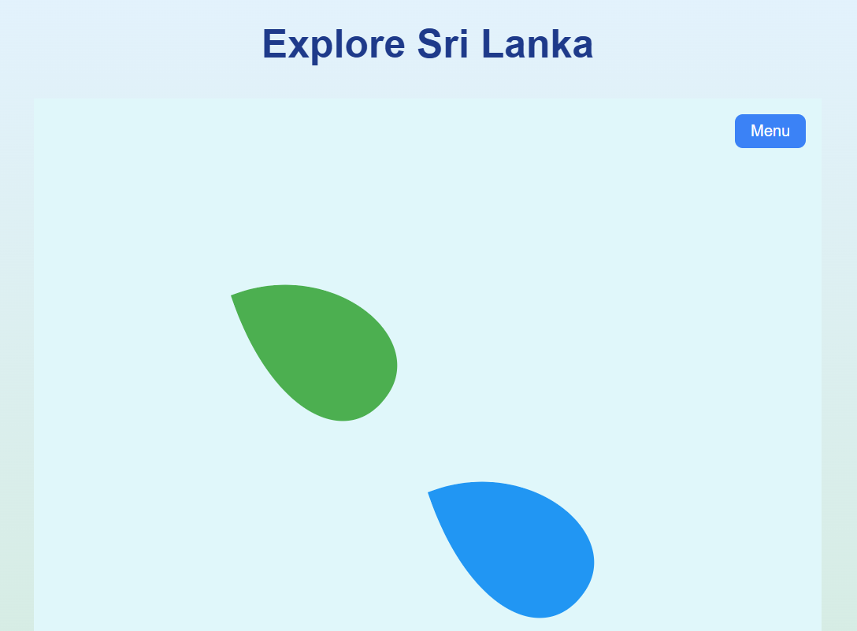

* Province Screen with challenge list

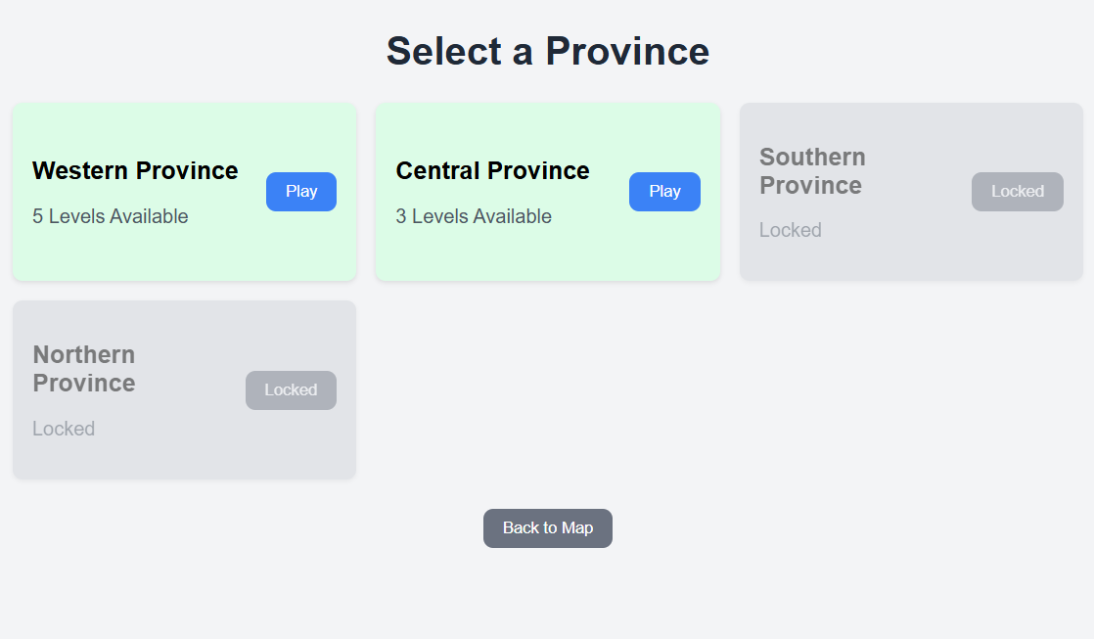

* SQL Editor Panel

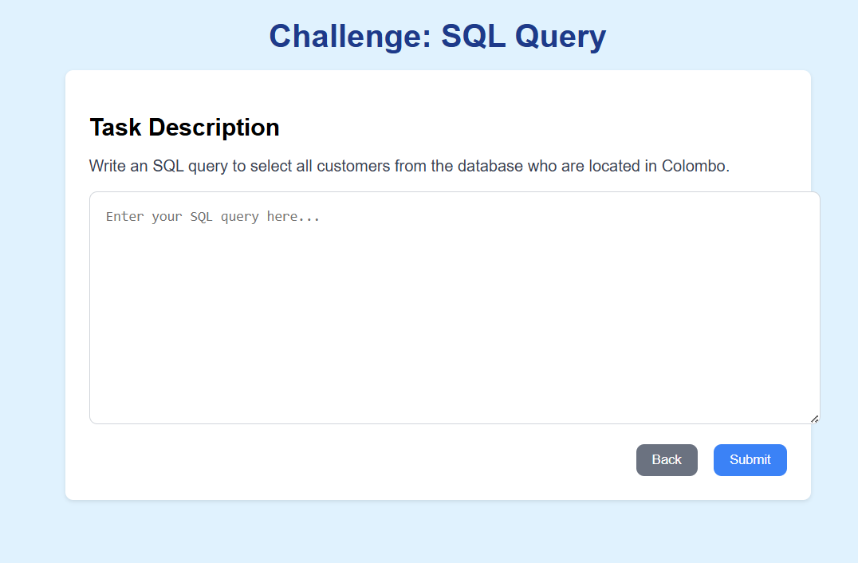

* Result Box (success/error)

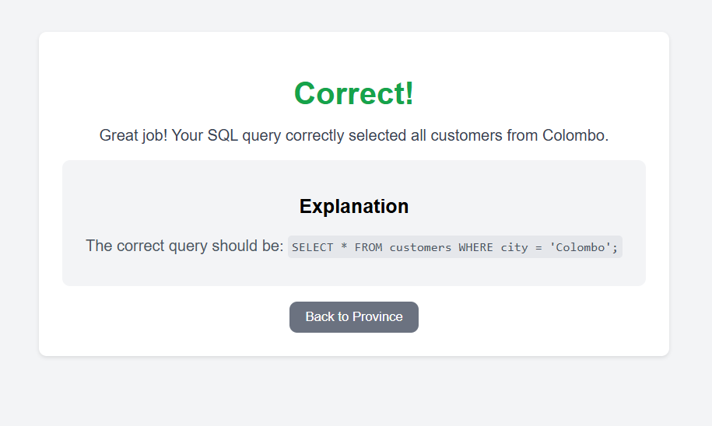

* Avatar Progress Dashboard

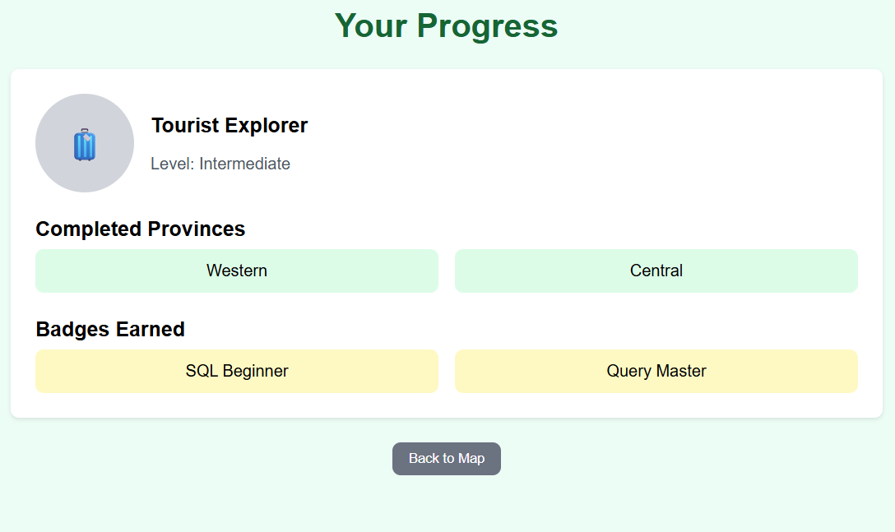

* Achievements Tab with badges

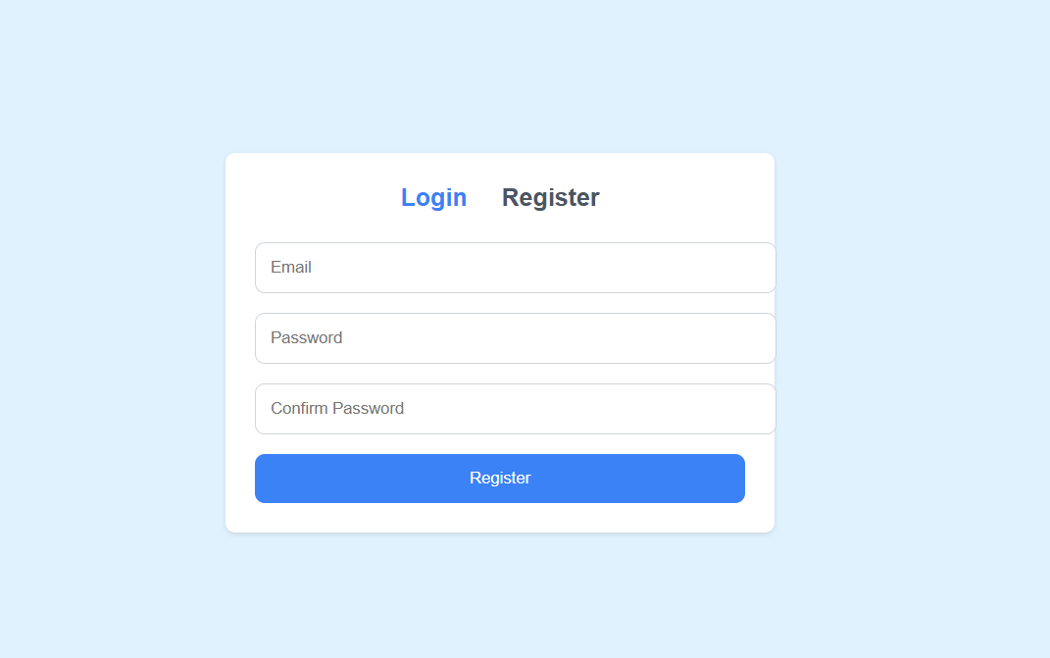

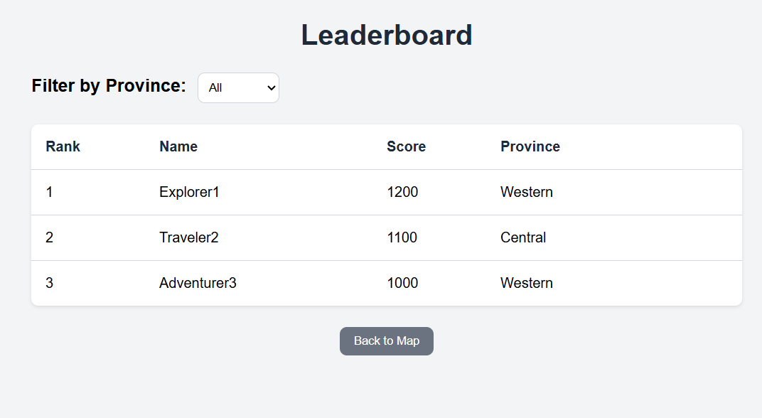

### 🔹 4.3 Game Features Summary

* Real-time SQL evaluator
* Story-based missions
* Leaderboard with retry count
* Adaptive hints with penalty
* Save & Resume Game
* Weekly duel challenge

## 5. Database Schema (Example SQL DDL)

CREATE TABLE tourists (  
 tourist_id INT PRIMARY KEY,  
 name VARCHAR(100),  
 email VARCHAR(100),  
 password VARCHAR(255)  
);  
  
CREATE TABLE provinces (  
 province_id INT PRIMARY KEY,  
 name VARCHAR(100),  
 level_theme VARCHAR(100)  
);  
  
CREATE TABLE hotels (  
 hotel_id INT PRIMARY KEY,  
 name VARCHAR(100),  
 province_id INT,  
 price DECIMAL(10,2),  
 FOREIGN KEY (province_id) REFERENCES provinces(province_id)  
);  
  
CREATE TABLE bookings (  
 booking_id INT PRIMARY KEY,  
 tourist_id INT,  
 hotel_id INT,  
 date DATE,  
 FOREIGN KEY (tourist_id) REFERENCES tourists(tourist_id),  
 FOREIGN KEY (hotel_id) REFERENCES hotels(hotel_id)  
);  
  
CREATE VIEW hotels_with_wifi AS  
SELECT name, price FROM hotels WHERE amenities LIKE '%WiFi%';

## 6. Educational Strategy

| **Objective** | **Implementation** |
| --- | --- |
| Teach SQL incrementally | Level-based learning per province |
| Motivate learners | Story, Avatar Progress, Rewards, Budget System |
| Support diverse learners | Hints, MCQs, Adaptive Help |
| Contextual learning | Tourism-inspired problems and realistic datasets |

**Bloom’s Taxonomy Mapping:**

* **Remember** → SELECT basics
* **Understand** → WHERE, ORDER BY
* **Apply** → JOIN, GROUP BY
* **Analyze** → Subqueries, HAVING
* **Evaluate** → Optimization logic
* **Create** → View creation, full report challenges

**7. Development Timeline**

|  |  |  |
| --- | --- | --- |
| **Week** | **Phase** | **Deliverables** |
| Week 1 | Analyze + Design | Learner needs, game concept, audience analysis, UI sketches, learning objectives |
| Week 2 | Development Start | Functional prototype, database schema setup, basic game logic |
| Week 3 | Testing + Improvement | SQL evaluator test, internal testing, user feedback, bug fixes |
| Week 4 | Implementation + Finalization | Beta release, final polish, data collection, evaluation report |

## 8. Testing & Evaluation

* SQL Evaluator test suite
* Manual gameplay testing (level completion, retries)
* Google Form: post-play feedback (engagement, clarity, fun)
* Analytics Dashboard:
  + Average time per challenge
  + Most common errors
  + Hint usage stats

## 

## 9. Future Enhancements

* Multiplayer duel mode (time-based query solving)
* Integration with voice assistant to read tasks
* Expand syllabus to include DDL, indexes, optimization plans
* IDE integration (e.g., export query to pgAdmin/MySQL Workbench)
* Real-time discussion boards or chat

## 10. Conclusion

By integrating the **ADDIE instructional design model** with the **Game Development Life Cycle (GDLC)**, *SQL Travels – Explore Sri Lanka with Queries* delivers a structured yet immersive learning experience tailored for modern learners. This hybrid approach enables systematic analysis of learner needs, pedagogically sound game design, and efficient development practices — all of which are essential for creating meaningful educational games.

The decision to adopt this model is firmly grounded in insights from the literature review. Studies emphasize that **gamification**, when aligned with instructional design principles, enhances learner motivation, knowledge retention, and engagement in technical subjects like SQL. The **ADDIE model ensures pedagogical coherence**, while **GDLC brings in iterative design, visual storytelling, and interactivity**, making it especially suitable for delivering abstract database concepts in an intuitive, relatable format.

Compared to traditional classroom-based methods, SQL Travels stands out by:

* Embedding **real-world tourism scenarios** into learning tasks
* Providing **immediate, adaptive feedback** and scaffolded progression
* Supporting **self-paced, visual, and inquiry-based learning styles**

Thus, this model was selected not only because it fits the learning objectives but because **the literature supports its effectiveness in game-based database learning contexts**. The result is a solution that improves SQL literacy while fostering **critical thinking**, **practical application**, and **intrinsic learner motivation**, making it ideal for both academic and self-learning environments.